COINS-EUR-Constantine I (306-337)-AE3-308-10-Nicomedia 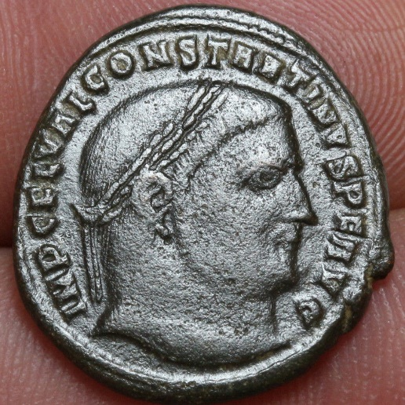 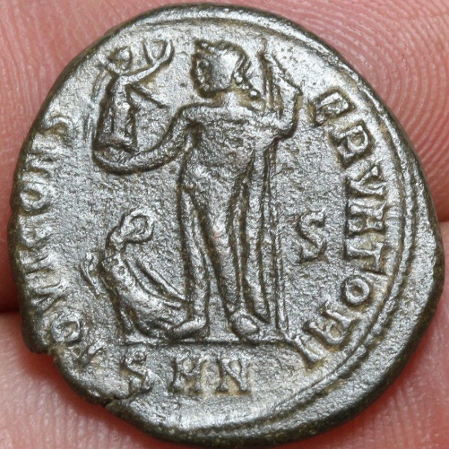

Constantine, as Filius Augustorum, AE Follis. 308-10 AD. FL VAL CONSTANTINVS FIL AVG, laureate head right / Jupiter standing left, chlamys across left shoulder, leaning on eagle-tipped sceptre, cornucopia at right foot, holding Victory on globe. S to right. Mintmark SMN. RIC VI 56

 The Caesar Constantine took the title Augustus in the West in 307 without the consent of the East. Before the East also recognized him as Augustus he was awarded the ephemeral imperial title Filius Augusti, "Son of the Augusti." "FIL AVG" and "FIL AVGG" appear only on coins of Constantine and Maximinus II, and, because both rejected the title, only on coins issued in their names from mints they did not control. The story begins in the context of the tetrarchic system in July 306 when the western Augustus Constantius I, terminally ill, gave his son Constantine imperial power. It ends in mid-310 when events forced the eastern Augustus Galerius to recognize Constantine and Maximinus II as Augusti. Coins illustrate the complicated power struggle during these four years.[1](http://augustuscoins.com/ed/FILAVGG/" \l "_edn1" \o ")

       The first tetrarchy was a new governmental system for sharing power that was created by Diocletian. After becoming emperor in 284, Diocletian chose a colleague, Maximian, to rule in the West in 286. Diocletian associated himself with the god Jupiter and Maximian with Hercules. To distinguish Maximian from other rulers with very similar names, he is sometimes called Herculius.[2](http://augustuscoins.com/ed/FILAVGG/" \l "_edn2" \o ") The first tetrarchy originated in 293 when each Augustus took a junior ruler, a Caesar, as an associate, to make a total of four simultaneous rulers (*tetra* means *four* in Greek, *arches* means *ruler*). Constantius became Caesar in the West and Galerius became Caesar in the East.[3](http://augustuscoins.com/ed/FILAVGG/" \l "_edn3" \o ") These two new rulers were not sons, or even close relatives, of the Augusti. At this stage the Jovian and Herculian dynasties relied on adoption of highly-qualified candidates who were then married into the dynasty.[4](http://augustuscoins.com/ed/FILAVGG/" \l "_edn4" \o ")

**The First Tetrarchy (293-305)**

**West**                           **East**

**Augustus**       Maximian             Diocletian

**Caesar**           Constantius             Galerius

          Mints in both East and West respectfully struck coins in the names of all four colleagues.

            The second tetrarchy began with the retirements of Diocletian and Maximian in 305 and the simultaneous elevation of Constantius and Galerius to Augusti and the creation of Severus II as western Caesar and Maximinus II as eastern Caesar.

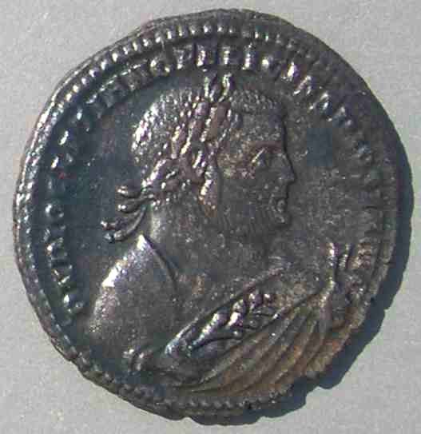

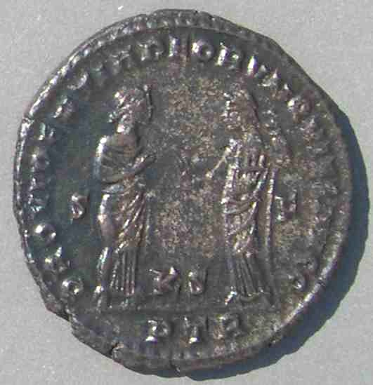  
  **Coin 1A  
  Diocletian**, who retired in 305 AD.   
  27 mm. 12:00.  
  Struck May 305 to early 307 at Trier.  
  DN DIOCLETIANO FELISSIMO SEN AVG  
  "SEN" for SENior, retired, augustus.  
  PROVIDENTIA DEORVM QVIES AVGG

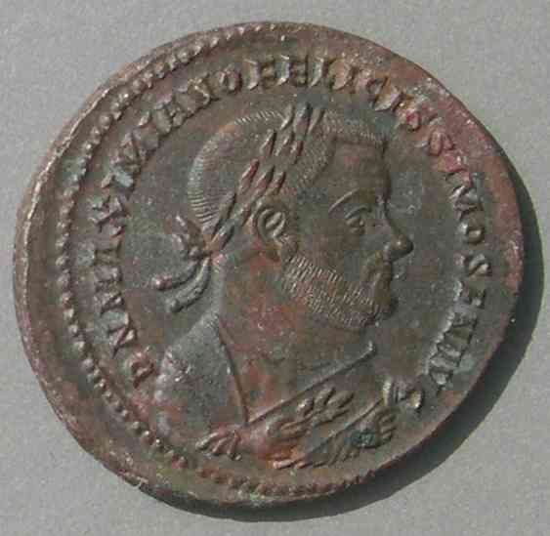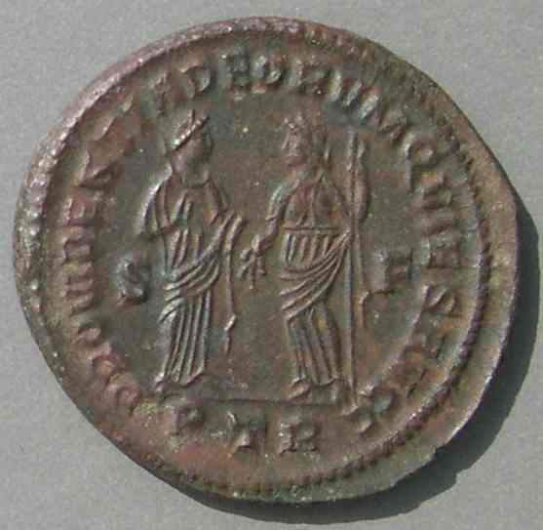   **Coin 1B**

**Maximian**, who retired in 305 AD.      
  27 mm.      
  Struck May 305 - early 307 at Trier.      
  DN MAXIMIANO FELICISSIMO SEN AVG       
  PROVIDENTIA DEORVM QVIES AVGG

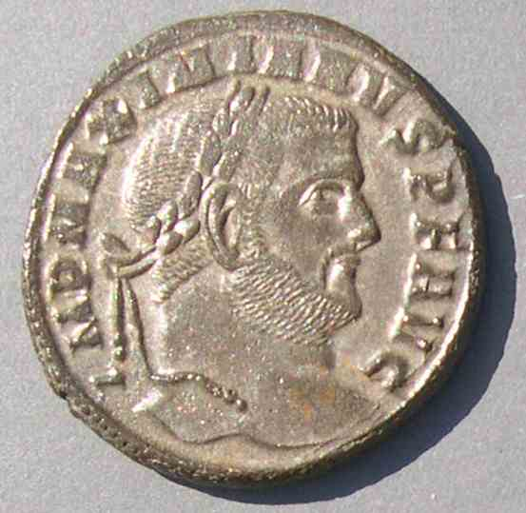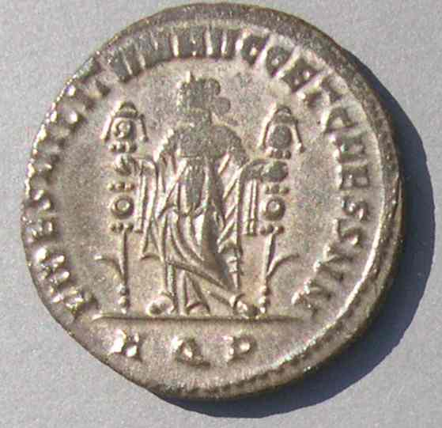

**Coin 1  
  Galerius**, as Augustus    
  27 mm.   
  Struck c. 305 at Aquileia.    
  IMP MAXIMIANVS PF AVG    
  FIDES MILTITVM AVGG ET CAESS NN

([Comments for collectors about the values of these coins](http://augustuscoins.com/ed/FILAVGG/comments.html).)

**The Second Tetrarchy (May 1, 305 - July 25, 306)**

**West**                           **East**

**Augustus**       Constantius                 Galerius [[1](http://augustuscoins.com/ed/FILAVGG/#C1)]

**Caesar**            Severus II                    Maximinus II

**Retired Augusti**: Diocletian [[1A](http://augustuscoins.com/ed/FILAVGG/#C1A)] and Maximian [[1B](http://augustuscoins.com/ed/FILAVGG/#C1B)]

**Relatives, soon to be rulers**:  Maxentius, son of Maximian

                                                                                                    Constantine, son of Constantius

**Regions of the Second Tetrarchy:**

            Constantius: Gaul, Spain, and Britain (primary mint, Trier)

Severus: The former territory of Herculius: Italy, Africa, Pannonia (including Siscia)

Galerius: Asia Minor, Greece, eastern Illyricum

            Maximinus: Syria and Egypt

The mints of 306-310 are given below in an [appendix](http://augustuscoins.com/ed/FILAVGG/#appendix). During the second tetrarchy mints all across the empire continued to strike coins for all four active rulers, as well as for Diocletian and Maximian as retired, "senior," emperors.[5](http://augustuscoins.com/ed/FILAVGG/" \l "_edn5" \o ")

            The Augustus we call Galerius was named Galerius Maximianus. His coins which used legends such as IMP MAXIMIANVS PF AVG [[1](http://augustuscoins.com/ed/FILAVGG/#C1)] can easily be confused with coins of Maximianus Herculius. Since Herculiuswas never titled Caesar on coins and Galerius was, when coins of "MAXIMIANVS" use the title NOB C instead of AVG, they belong to Galerius. Galerius's coins as Augustus can be distinguished by type, size, and sometimes by the legend containing GAL VAL preceding MAXIMIANVS [[2](http://augustuscoins.com/ed/FILAVGG/#C2)].  However, one must be careful to note that only the extra "A" distinguishes (GAL VAL) MAXIMIANVS (Galerius) from (GAL VAL) MAXIMINVS (Maximinus [[3](http://augustuscoins.com/ed/FILAVGG/#C3)]), both as Caesar and as Augustus.

            Again the two new rulers were not natural sons of the Augusti, but were adopted into the dynasties. This is remarkable, especially considering Maximian Herculius had an eligible son, Maxentius, and Constantius had an eligible son, Constantine. Even the philosopher emperor Marcus Aurelius had chosen his son, Commodus, to succeed him rather than continue the adoptive system that had resulted in "the good emperors" of the second century. However, reversion to a dynasty based on blood relationship was presaged with the appointment of Maximinus, who was a nephew of Galerius and not an experienced soldier.

            The upcoming events occur largely in the west, leaving the eastern situation basically unchanged. That is, Galerius remained eastern Augustus and Maximinus remained second in command in the east until mid 310. Nevertheless, coins minted in the East reflect the turmoil in the West as new rulers and titles were or were not accepted in the East as legitimate.

            In July 306, when Constantius was terminally ill on campaign at York, England, he exercised his right as Augustus to award his own son, Constantine, *imperium*, that is, imperial power. The western army of Constantius acclaimed Constantine. Galerius was left out of the selection process. When Constantius died July 25, the Caesar Severus was promoted to Augustus of the West as expected [[4](http://augustuscoins.com/ed/FILAVGG/#C4)], and there was nothing for Galerius to do but accept the popular son of Constantius, Constantine, as the new western Caesar [[5](http://augustuscoins.com/ed/FILAVGG/#C5)]. Constantine took over Constantius's portion of the empire and began minting coins as Caesar, with Trier his primary mint [6](http://augustuscoins.com/ed/FILAVGG/" \l "_edn6" \o ") [[6]](http://augustuscoins.com/ed/FILAVGG/#C6).

**The third tetrarchy (July 25, 306 - c. April, 307)**

**West**                           **East**

**Augustus**        Severus II [[4](http://augustuscoins.com/ed/FILAVGG/#C4)]           Galerius

**Caesar**            Constantine [[5](http://augustuscoins.com/ed/FILAVGG/#C5), [6](http://augustuscoins.com/ed/FILAVGG/#C6)]        Maximinus II

            During this short period, mints of each of the four legitimate rulers struck for the other legitimate rulers and the two retired emperors.

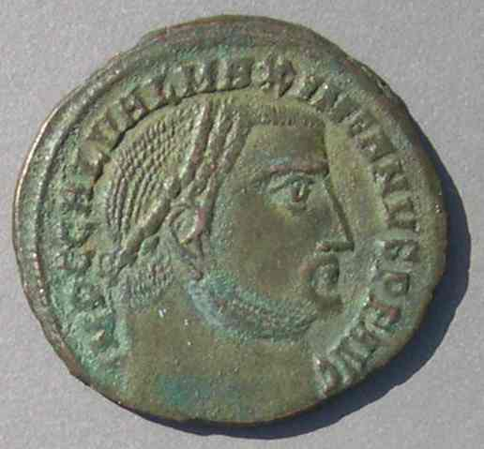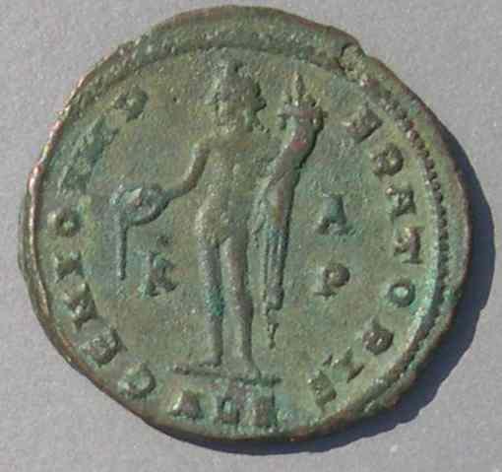

**Coin 2  
  Galerius**, as Augustus  
  25 mm.  
  Struck late 308 - 310  
  at Alexandria  
  IMP C GAL VAL MAXIMIANVS PF AVG  
  [not MAXIMINVS, compare to the next coin.]  
  GENIO IMPERATORIS

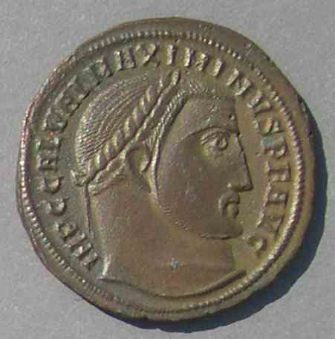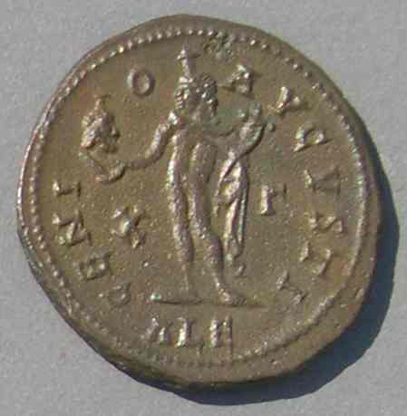

**Coin 3**  
**Maximinus II**  
  23 mm. 12:00.  
  Struck 312 as Augustus at his own mint Alexandria  
  IMP C GAL VAL MAXIMINVS PF AVG  
  [not MAXIMIANVS, compare to the previous coin.]  
  GENIO AVGVSTI

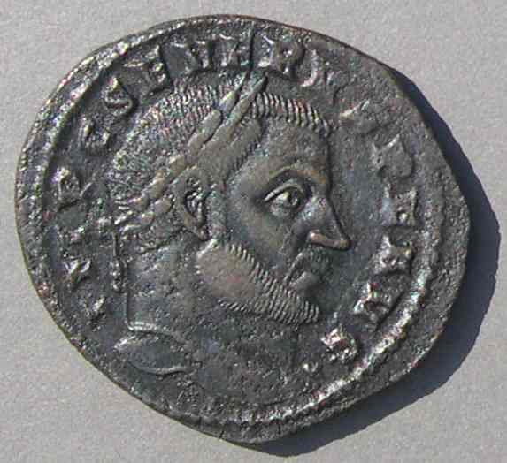

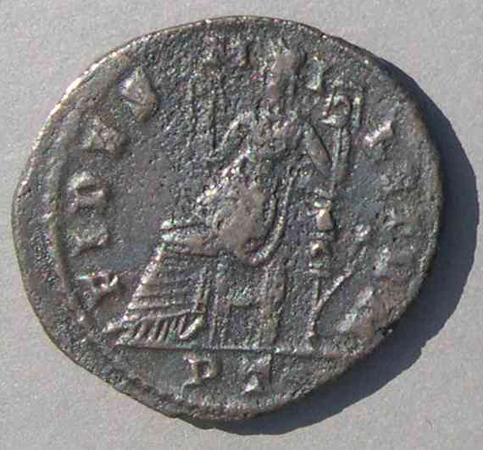

  **Coin 4**  
**Severus II**  
  28-25 mm. 12:00.  
  Struck December 306  
  at Ticinum, his own mint.  
  IMP SEVERVS PF AVG  
  FIDES MILITVM

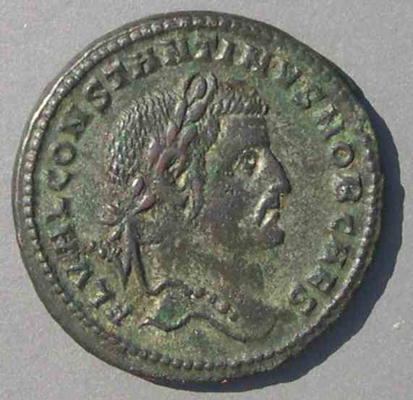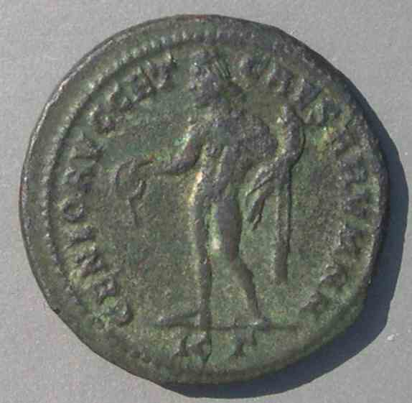

**Coin 5**   
**Constantine** as Caesar   
  27 mm. 10.60 grams. 6:00.   
  Struck 306 at Cyzicus, a mint of Galerius.   
  FL VAL CONSTANTINVS NOB CAES   
  GENIO AVG ET CAESARVM NN

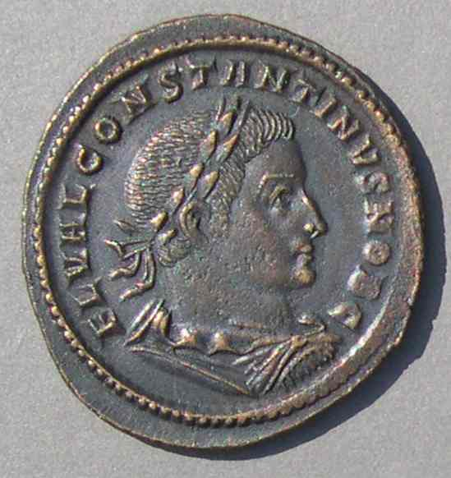

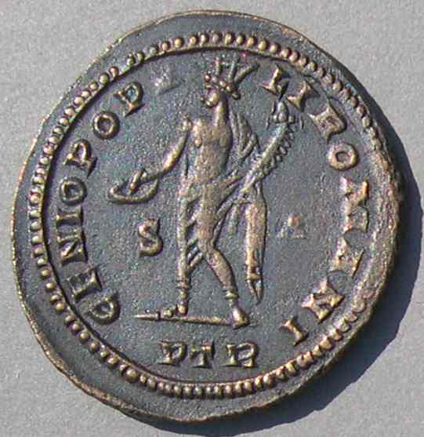  
**Coin 6  
  Constantine** as Caesar   
   29-28 mm. 5:30.  
   Struck c. Spring 307 at Trier, his own mint.  
   FL VAL CONSTANTINVS NOB C  
   GENIO POPVLI ROMANI

   From 293 to 306 was apparently long enough to accustom people to this new system with two Augusti and two Caesars. Every member was according respect to every other member. But we can imagine Maximinus II must have been irritated to see Severus attain the status of Augustus after only 1 year. Also, quite a few people must have been concerned that Constantine had been able to advance without the consent of the other rulers by the old tried-and-true military method, making an end run around the system. If he could, why couldn't they?

    Maxentius did. Son of the retired Herculian Augustus Maximian, he usurped power at Rome in Severus' territory on October 28, 306, while Severus was in the north. Most soldiers near the traditional center of the empire had served under Maximian Herculius and looked favorably on his son's coup. Maxentius knew he had formidable opponents and enlisted the aid of his father Maximian, who more-than-willingly left retirement and assumed his former position of Augustus. Who was to stop them?

    Rare coins show the hesitant nature of Maxentius' entry in the sweepstakes. He began with the un-tetrarchic inferior title "Princips," while recognizing his father as active (as opposed to retired) Augustus [[7](http://augustuscoins.com/ed/FILAVGG/#C7)]. He apparently took the supreme title Augustus c. summer 307 [[8](http://augustuscoins.com/ed/FILAVGG/#C8)], well after the revolt, but before he struck many coins in his own name.

      The revolt necessarily provoked an immediate reaction from the legitimate members of the system, especially Galerius and Severus. Maxentius tried to stay on the good side of Constantine by minting for him [[9](http://augustuscoins.com/ed/FILAVGG/#C9)], but Constantine did not return the favor.[7](http://augustuscoins.com/ed/FILAVGG/" \l "_edn7" \o ")

**Mints striking for various rulers, Late 306 - Summer 307**

**(i.e. Revolt of Maxentius - death of Severus)**

**For Maxentius**: Only his own mints. Only very rare coins as Princips until c. summer 307 and coins as Caesar only at Carthage (which probably expected Maximian Herculius to be the sole western Augustus). Coins as Augustus commence after summer 307 [[8](http://augustuscoins.com/ed/FILAVGG/#C8)].

**For Maximian** Herculius, as active, senior, Augustus: Mints of Maxentius [[7](http://augustuscoins.com/ed/FILAVGG/#C7)]. As senior Augustus at Constantine's mints [[10](http://augustuscoins.com/ed/FILAVGG/#C10)]. As retired Augustus with Diocletian, at Constantine's mints and throughout the East.

**For Constantine as Caesar**: Mints of Constantine [[6](http://augustuscoins.com/ed/FILAVGG/#C6)], Maxentius, Severus, Galerius [[5](http://augustuscoins.com/ed/FILAVGG/#C5)], and Maximinus [[11](http://augustuscoins.com/ed/FILAVGG/#C11)]. That is, mints of all "legitimate" rulers and also mints of the usurper Maxentius.

**For Severus and Galerius**: Mints of Severus [[4](http://augustuscoins.com/ed/FILAVGG/#C4)], Galerius, Maximinus, and Constantine, but not mints of Maxentius.

**For Maximinus II**: Mints of Severus, Galerius, Maximinus, and Constantine [[12](http://augustuscoins.com/ed/FILAVGG/#C12)], and Carthage, a mint of Maxentius.

            In summary, the four recognized members of the third tetrarchy struck for each other, but not for Maxentius. Maxentius struck for himself, for his father as Augustus, for Constantine and Maximinus as Caesars, but not for the other two members of the tetrarchy.

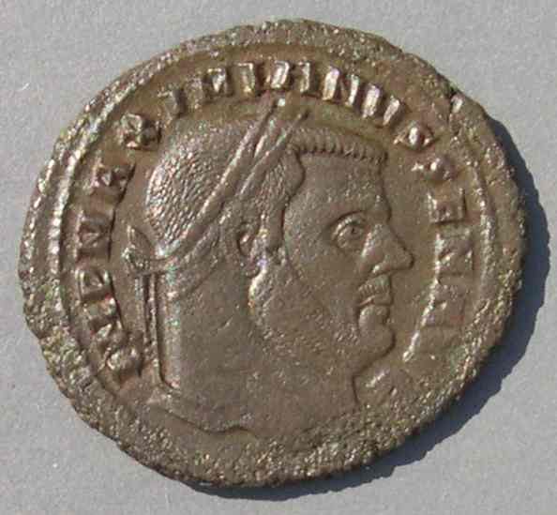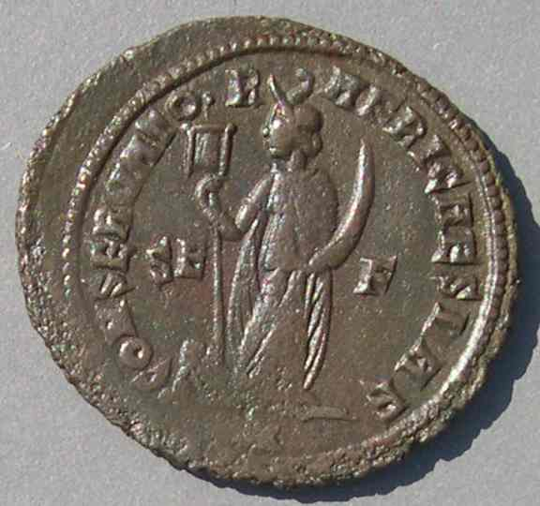

  **Coin 7   
  Maximian**, as active Augustus  
  29-27 mm. 12:00.  
  Struck late 306 - early 307   
  at Carthage, a mint of Maxentius, his son.   
  IMP MAXIMIANVS SEN AVG  
  CONSERVATOR AFRICAE SVAE/big>

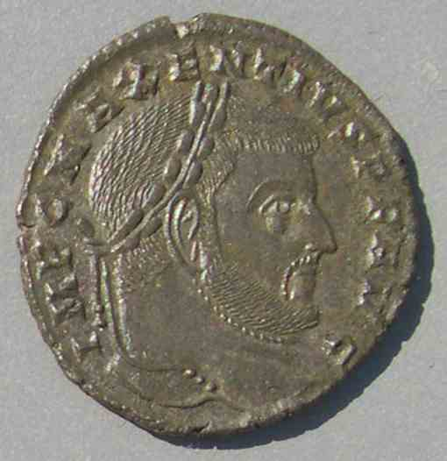

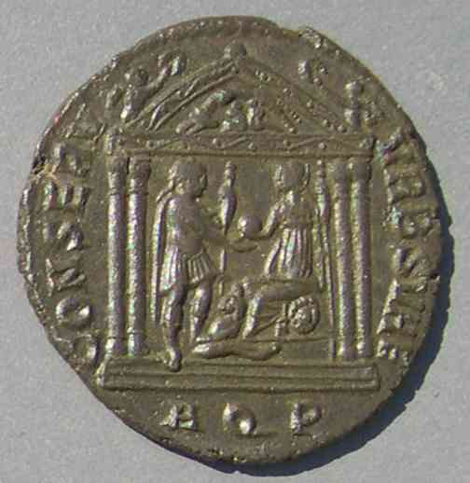

  **Coin 8  
  Maxentius**  
  26-25 mm. 6.55 grams. 12:00.  
  Struck as Augustus, late summer 307  
  at Aquileia, his own mint.   
  IMP C MAXENTIVS PF AVG  
  CONSERV VRB SVAE

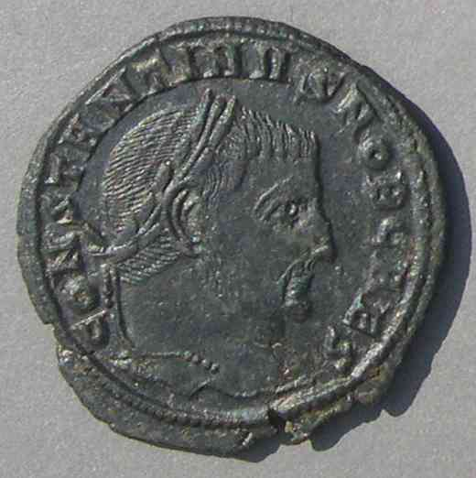

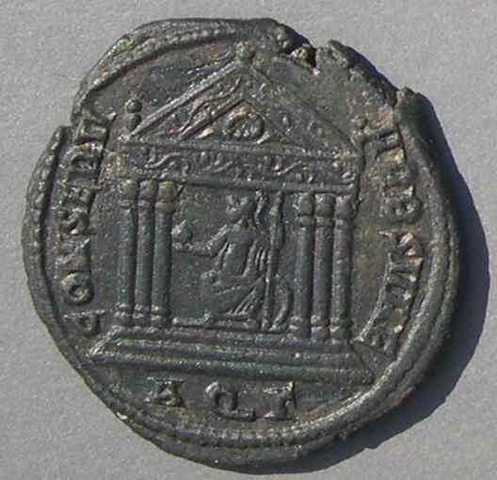

  **Coin 9  
  Constantine**, as Caesar  
  26 mm. 6:00.  
  Struck late summer, 307 at Aquileia, a mint of Maxentius.     
  CONSTANTINVS NOB CAES   
  CONSERV VRB SVAE

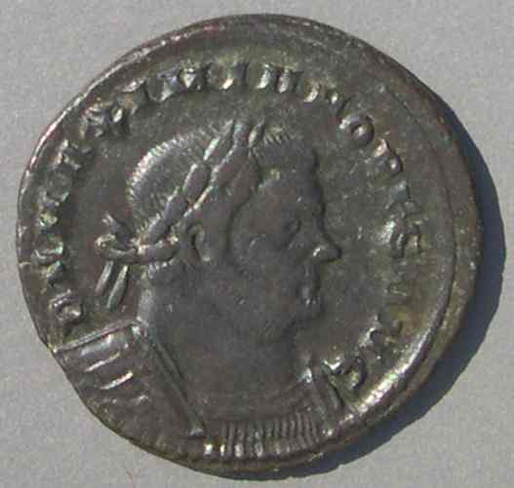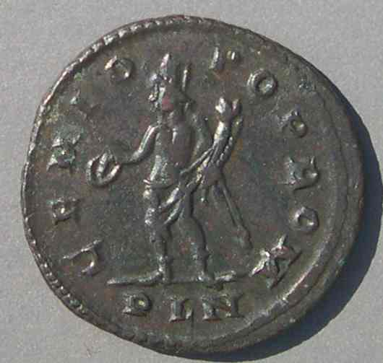

**Coin 10   
  Maximian** as Senior Augustus.  
  25-24 mm.  
  at London, a mint of Constantine.  
  Struck summer 307.  
  DN MAXIMIANO S AVG  
  "S" for Senior.  
  GENIO POP ROM

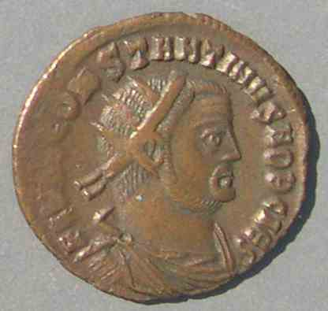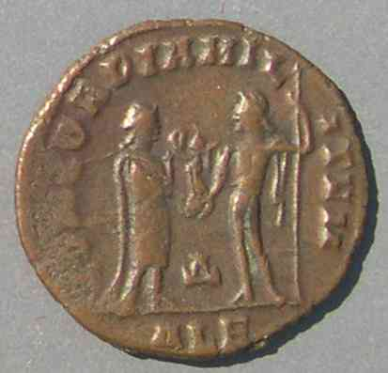  
**Coin 11  
  Constantine**, as Caesar  
  20 mm.  
  Struck Autumn 306 - early 307 at Alexandria,  
  a mint of Maximinus II.  
  FL VAL CONSTANTINVS NOB CAES  
  CONCORDIA MILITVM

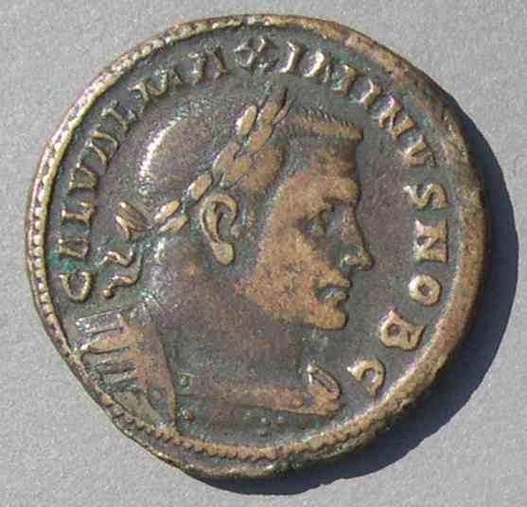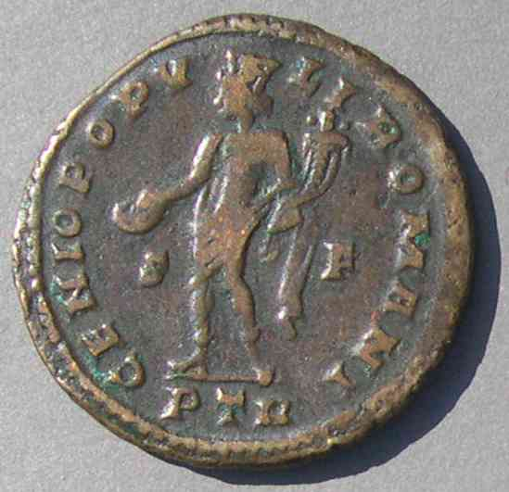

**Coin 12  
  Maximinus II**, as Caesar  
  27 mm.  
  Struck 1 May 305 - early 307  
  at Trier, a mint of Constantine  
  GAL VAL MAXIMINVS NOB C  
  GENIO POPVLI ROMANI

    Galerius ordered Severus to recover Rome. After all, Severus was supposed to be Augustus of the West, although his capital was Milan and his mints were Ticinum [[4](http://augustuscoins.com/ed/FILAVGG/#C4)], Aquileia, and Siscia. Severus' advance toward and subsequent siege of Rome in Spring 307 failed dismally because his soldiers, many of whom had served under Maximian, melted away as they succumbed to bribes or were simply unwilling to fight. At the approach of an army under Maximian, Severus retreated to Ravenna where he was forced to surrender. At first held as a hostage against Galerius, he was soon put to death.

            As Severus' failure became apparent, Galerius decided to try to recover Rome himself.  Anticipating the attack, Maximian fortified Rome and then went to enlist Constantine's aid. He used his authority as an active Augustus to confirm Constantine in power and cemented the relationship by giving the hand of his daughter, Fausta, to Constantine in marriage. Galerius' attack failed for the same reasons as Severus', and he retreated to Illyricum, perhaps even before the return of Maximian to Rome. So Maxentius controlled Carthage, Rome, Ticinum, and Aquileia, but not Siscia.

            All this happened by summer of 307. With the western Augustus Severus dead and the position vacant, it is not surprising that Constantine took the title of Augustus (July 25, 307)[8](http://augustuscoins.com/ed/FILAVGG/" \l "_edn8" \o ") [[13](http://augustuscoins.com/ed/FILAVGG/#C13)]. Nor is it surprising that Maxentius did, too [[8](http://augustuscoins.com/ed/FILAVGG/#C8)].

**Late Summer 307 - Late 308**

**(i.e. After Constantine declared Augustus, but before the Conference at Carnuntum)**

**West**                                                                         **East**

**Augustus**       Maxentius, Maximian [[14,15](http://augustuscoins.com/ed/FILAVGG/#C14)], Constantine [[13](http://augustuscoins.com/ed/FILAVGG/#C13)]                                   Galerius

**Caesar**                                    (none)                                                                    Maximinus II

   [Rulers did not necessarily recognize each other's titles, unlike under the tetrarchic system.]

**Mints striking for various rulers**, **Late Summer 307 - Late 308**

**For Constantine**: Constantine's mints [[13](http://augustuscoins.com/ed/FILAVGG/#C13)], and Maxentius' mints until the break in Spring 308 [[9](http://augustuscoins.com/ed/FILAVGG/#C9)].

**For Maxentius**: Only his own mints [[8](http://augustuscoins.com/ed/FILAVGG/#C8)].[9](http://augustuscoins.com/ed/FILAVGG/" \l "_edn9" \o ")

**For Maximian Herculius** as an active ruler: Constantine's mints [[15](http://augustuscoins.com/ed/FILAVGG/#C15)], and Maxentius' mints until the break in Spring 308 [[14](http://augustuscoins.com/ed/FILAVGG/#C14)]. As retired with Diocletian: Eastern mints [[16](http://augustuscoins.com/ed/FILAVGG/#C16)].

**For Galerius and for Maximinus II**: Mints of Galerius and Maximinus.[10](http://augustuscoins.com/ed/FILAVGG/" \l "_edn10" \o ")

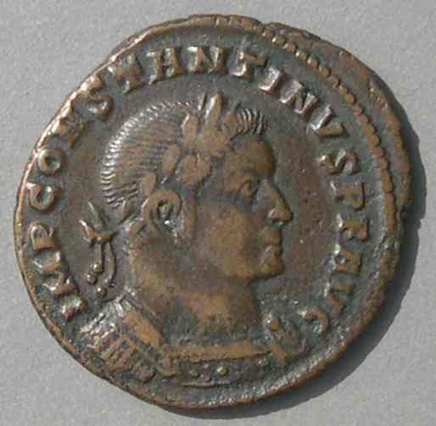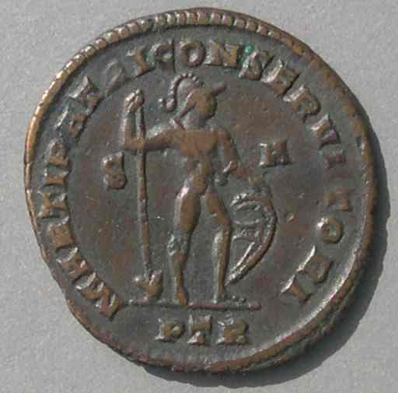  
  
**Coin 13  
  Constantine**  
  Struck autumn 307-end of 308 at Trier  
  IMP CONSTANTINVS PF AVG  
  MARTI PATRI CONSERVATORI

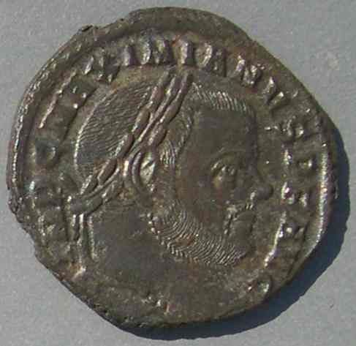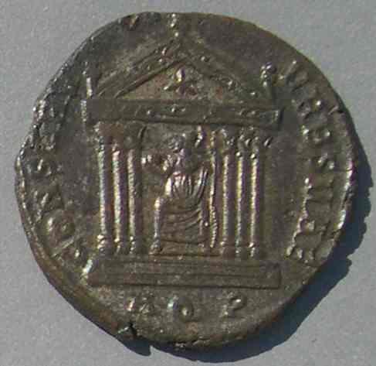  
  
**Coin 14  
  Maximian,**as active Augustus  
  25 mm.  
  Struck Autumn 307 - c.309/310  
  at Aquileia.  
  IMP C MAXIMIANVS PF AVG  
  CONSERV VRB SVAE

**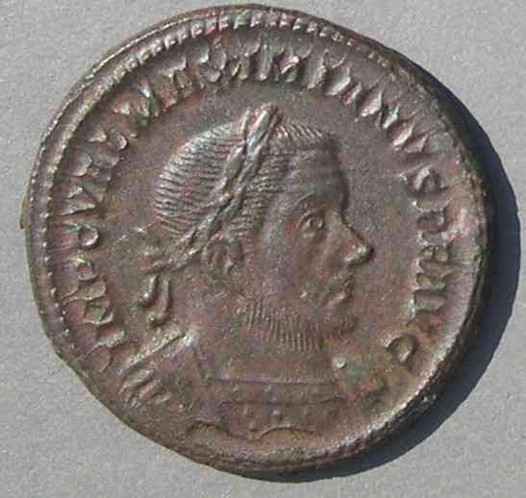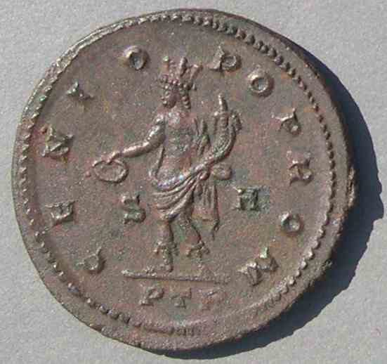**

### Coin 15   Maximian, as active Augustus   27 mm.   Struck Autumn 307 - end of 308     at Trier, a mint of Constantine.   IMP C VAL MAXIMIANVS PF AVG   GENIO POP ROM

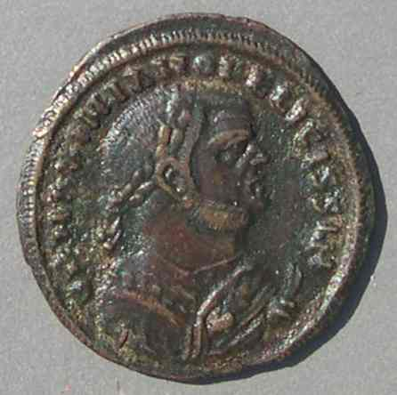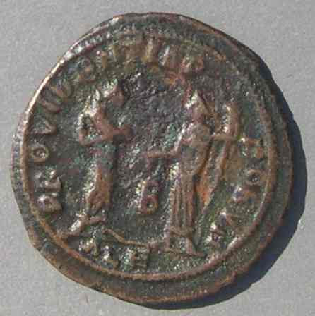

**Coin 16**  
 **Maximian**, who retired in 305 AD.      
  22 mm. 3.06 grams. 12:00.      
  Struck early to mid 308 at Alexandria.      
  DN MAXIMIANO FELICISSIM        
  PROVIDENTIA DEORVM

    Maxentius' claim to fame was founded on his being the son of Maximian, but Maxentius kept power for himself. Maximian tried, but was unable to convince the army to follow him instead of his son. This broke their alliance and Maximian sought refuge with Constantine (Spring 308). This relocation was mutually beneficial. Maximian joined someone with military power who was willing to accord him the status of active Augustus. Constantine gained the support of a well-known elder statesman.

   The respectful recognition on coins of co-rulers that had been a remarkable aspect of the tetrarchic system gave way to recognition based solely on power politics. Maxentius was a usurper and his omission from the coins of the mints of Constantine and the eastern rulers is only to be expected. However, Maxentius minted for Constantine until the break with his father in Spring 308. Constantine did not mint for Maxentius or the eastern rulers.

    The death of Severus and Constantine's promotion to Augustus without eastern approval left the East unwilling to recognize anyone in the West. When Severus' death caused his disappearance from issues at eastern mints, Constantine disappeared too.[11](http://augustuscoins.com/ed/FILAVGG/" \l "_edn11" \o ")

    The western rulers Maxentius, Maximian, and Constantine, all claiming to be Augustus, clearly had rejected the method of orderly succession formerly associated with the tetrarchic system. Nevertheless, each probably would have been pleased to have no rivals and be the only western Augustus, recognized by the East in a restored system.

   Galerius, the senior emperor, wanted to restore the old order. He persuaded the retired Diocletian to lend his authority to a reconciliation conference to be held at Carnuntum (on the Rhine, just east of Vienna) in late 308.[12](http://augustuscoins.com/ed/FILAVGG/" \l "_edn12" \o ")Maximian also came. The results were (1) Maximian was forced to retire again, (2) a new man, Licinius, was promoted to Augustus of the West without ever having been Caesar, (3) Constantine was demoted back to Caesar, and (4) Maxentius was declared a public enemy. That these decisions did not please everybody is obvious.

**The Carnuntum Decisions, Late 308**

**West                                East**  
  
                                        **Augustus**                           Licinus                                Galerius  
                                           **Caesar**Constantine                     Maximinus II  
  
                                          Maximian--retired, for the second time  
                                          Maxentius--"public enemy"

Maximian Herculius lost all rank and became a "private citizen." Because he had no army, he could only go back to live under the wing of Constantine. Of course, Constantine refused his demotion, and Maximinus protested the elevation of Licinius. Galerius tried to strike a compromise by inventing and awarding the title "Filius Augusti" to these two. Regardless of whether it was supposed to be a rank higher than Caesar, Maximinus would not have it and continued to strike coins for himself with his old title Caesar [[17](http://augustuscoins.com/ed/FILAVGG/#C17)]. Constantine continued to strike with the title Augustus. Coins show each as FIL AVG or FIL AVGG, but only at mints they did not influence. Galerius, who thought up the idea, struck FIL AVGG coins (with two G's) for both Constantine and Maximinus II at Siscia and Thessalonica [[18-22](http://augustuscoins.com/ed/FILAVGG/#C18)]. In addition, FIL AVG coins (with one G) were struck by Galerius for Constantine at Nicomedia and by Maximinus for Constantine at Antioch and Alexandria [[23-25](http://augustuscoins.com/ed/FILAVGG/#C23)].[13](http://augustuscoins.com/ed/FILAVGG/" \l "_edn13" \o ")   Maximinus did not strike them for himself [[17](http://augustuscoins.com/ed/FILAVGG/#C17)]. Other eastern mints simply did not strike for Constantine at all. Constantine did not strike for Galerius ever again, or for Maximinus until he became Augustus with Constantine in mid 310.

**FIL AVG(G) types of Constantine and Maximinus II (late 308- mid 310)**

**mint                          ruler(s)                         reverse**

                        Siscia                            both                        GENIO AVGVSTI [[18](http://augustuscoins.com/ed/FILAVGG/#C18), [21](http://augustuscoins.com/ed/FILAVGG/#C21)]

                    Thessalonica                     both                        GENIO CAESARIS [[19](http://augustuscoins.com/ed/FILAVGG/#C19), [22](http://augustuscoins.com/ed/FILAVGG/#C22)]

                    Thessalonica                     both                        VIRTVTI EXERCITVS [[20]](http://augustuscoins.com/ed/FILAVGG/#C20)

                    Nicomedia                   Constantine                 GENIO CAESARIS CMH [14](http://augustuscoins.com/ed/FILAVGG/" \l "_edn14" \o ") [[23](http://augustuscoins.com/ed/FILAVGG/#C23)]

                    Nicomedia                   Constantine                  VIRTVTI EXERCITVS CMH

                      Antioch                     Constantine                 GENIO FIL AVGG [[24](http://augustuscoins.com/ed/FILAVGG/#C24)]

                      Antioch                      Constantine                 GENIO CAESARIS

                    Alexandria                   Constantine                 GENIO CAESARIS [[25](http://augustuscoins.com/ed/FILAVGG/#C25)]

                    Alexandria                   Constantine                 VIRTVTI EXERCITVS

**Notes**: The three GENIO legends are all associated with the same type: Genius standing left holding patera and cornucopia. This is the same design as on the common GENIO POPVLI ROMANI type. The VIRTVTI EXERCITVS type shows a helmeted Virtus advancing right in military dress, holding transverse spear in his right hand and a trophy over his shoulder with his left. It was new with the first issue of Licinius [[26](http://augustuscoins.com/ed/FILAVGG/#C26)].

            At Siscia and Thessalonica, obverses have FIL AVGG with two Gs.

            At Nicomedia, Antioch, and Alexandria, obverses have FIL AVG with only one G.

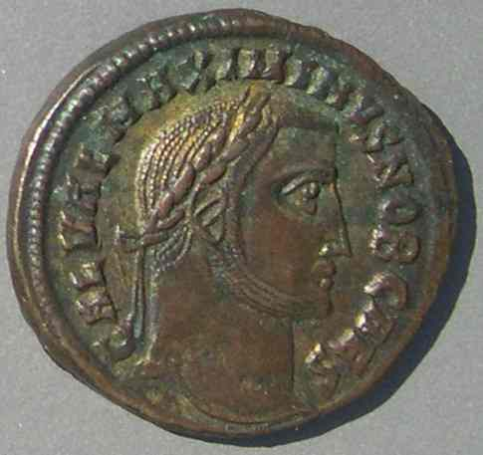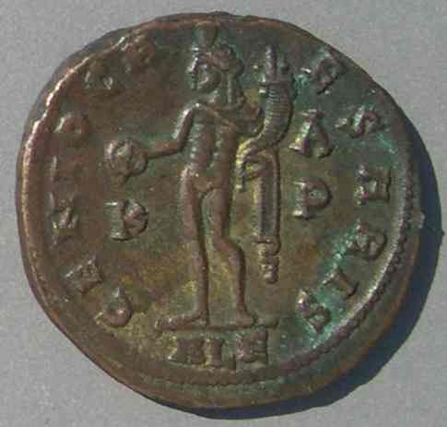 **Coin 17  
  Maximinus II**, as Caesar  
  25 mm.  
  Struck late 308 - 310  
  at Alexandria, his own mint,  
  without the FIL AVG title.  
  GAL VAL MAXIMINUS NOB CAES  
  GENIO CAESARIS

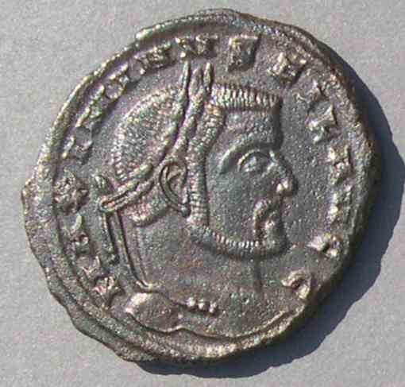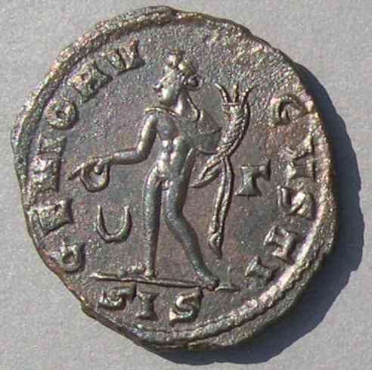  
 **Coin 18  
  Maximinus II**, as FIL AVGG  
  25-23 mm.  
  Struck c.309 - May 310  
  at Siscia, a mint of Galerius  
  MAXIMINVS FIL AVGG  
  GENIO AVGVSTI

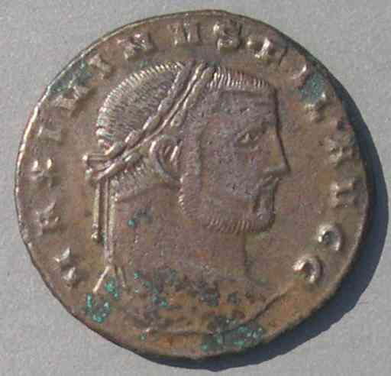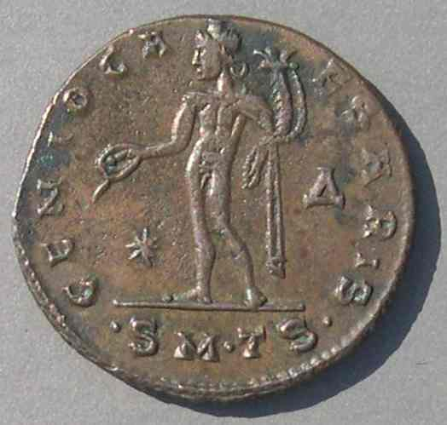  
  **Coin 19  
  Maximinus II**, as FIL AVGG  
  25 mm.  
  Struck late 308 - May 310  
  at Thessalonia, a mint of Galerius.  
  MAXIMINVS FIL AVGG  
  GENIO CAESARIS

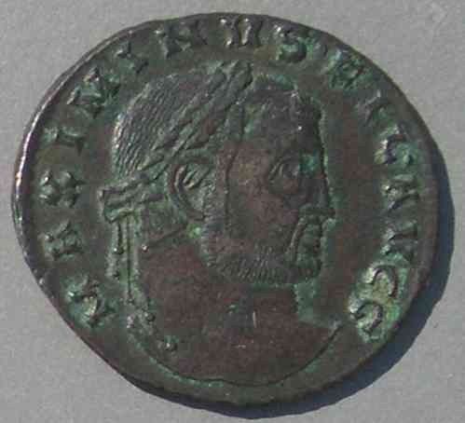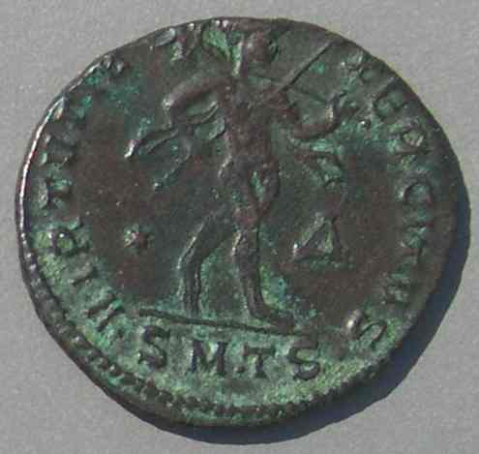  
  
**Coin 20  
  Maximinus II**, as FIL AVGG  
  25-23 mm.  
  Struck late 308 - May 310  
  at Thessalonica, a mint of Galerius  
  MAXIMINVS FIL AVGG  
  VIRTVTI EXERCITVS

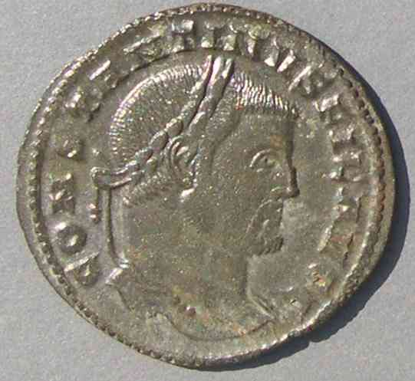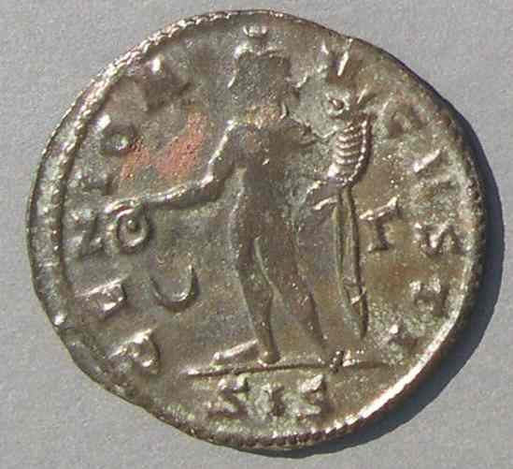  
**Coin 21  
  Constantine**, as FIL AVGG  
  27 mm.  
  Struck late 308 - May 310  
  at Siscia, a mint of Galerius  
  CONSTANTINVS FIL AVGG  
  GENIO AVGVSTI

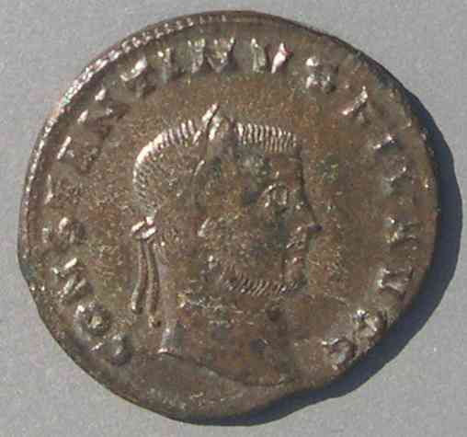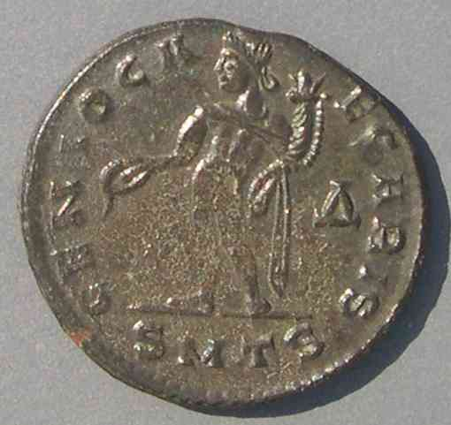  
  
  **Coin 22  
  Constantine**, as FIL AVGG  
  25 mm.  
  Struck late 308 - May 310  
  at Thessalonica, a mint of Galerius  
  CONSTANTINVS FIL AVGG  
  GENIO CAESARIS

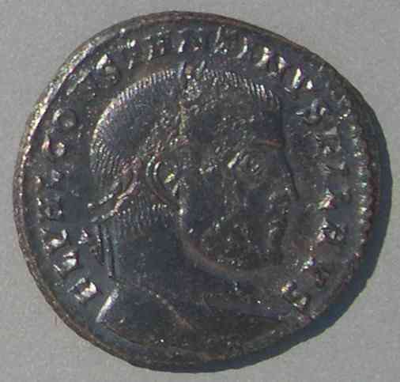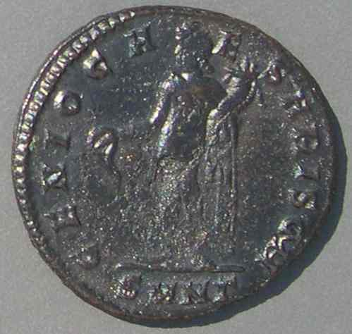  
**Coin 23  
  Constantine**, as FIL AVG  
  25 mm.  
  Struck late 308 - May 310  
  at Nicomedia, a mint of Galerius  
  CONSTANTINVS FIL AVS [sic]  
  [only one G, written as S]  
  GENIO CAESARIS CMH [elided]

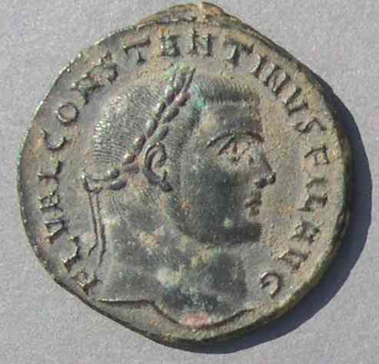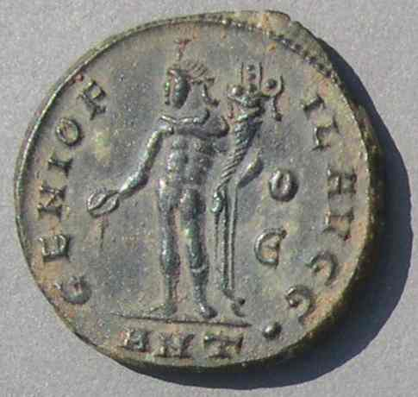  
  
**Coin 24  
  Constantine**, as FIL AVG  
  24 mm.  
  Struck c. early to later 309  
  at Antioch  
  FL VAL CONSTANTINVS FIL AVG  
  [only one G]  
  GENIO FIL AVGG  
  (This is the only variety mentioning FIL AVGG on the reverse.)

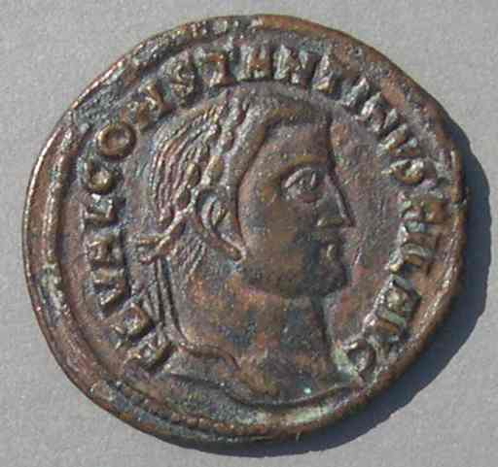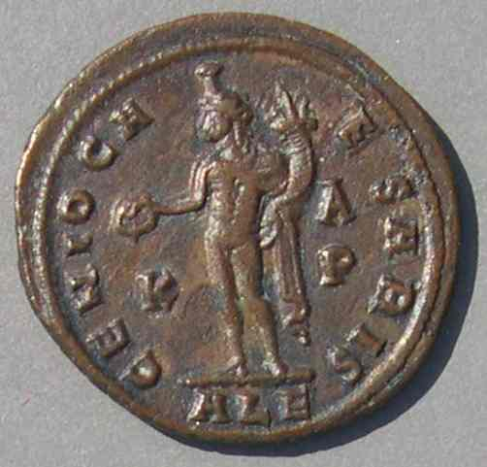  
  
**Coin 25  
  Constantine**, as FIL AVG  
  25 mm.  
  Struck late 308 - May 310  
  at Alexandria  
  FL VAL CONSTANTINVS FIL AVG  
  [only one G]  
  GENIO CAESARIS

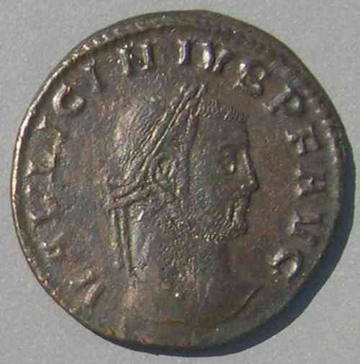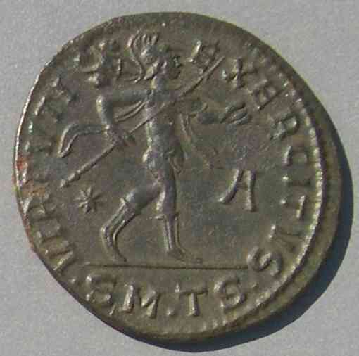  
**Coin 26  
  Licinius**, as Augustus  
  (he was never Caesar, but his son was)  
  26 mm.  
  Struck late 308 - May 310  
  at Thessalonica (alongside the FIL AVGG pieces)  
  VAL LICINIVS PF AVG  
  VIRTVTI EXERCITVS

Galerius was responsible for the Balkans and Asia Minor. Licinius held only the former territory of Severus, minus that held by Maxentius. After the end of our time period the deaths of the eastern rulers left Licinius to inherit the East. Because most of his coins are later issues that mention IOVI CONSERVATORI, collectors are likely to think of Licinius as a Jovian, eastern, emperor [[27](http://augustuscoins.com/ed/FILAVGG/#C27)]. Nevertheless, technically he began as the western emperor, with Pannonia (including Siscia) as his territory.

**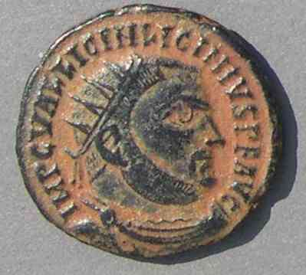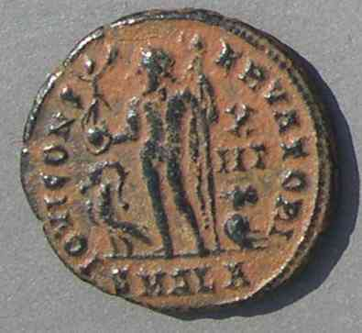   Coin 27    
   Licinius**, as Augustus  
  19 mm.  
  Struck 321-324  
  at Alexandria  
  IMP C VAL LICIN LICINIVS PF AVG  
  IOVI CONSERVATORI

**Mints striking for various rulers, late 308 - mid 310**

**(i.e. After the Conference at Carnuntum)**

**For Galerius**: Only mints of Galerius [[28](http://augustuscoins.com/ed/FILAVGG/#C28)] and Maximinus.

**For Maximinus II**: His own mints, as Caesar [[17](http://augustuscoins.com/ed/FILAVGG/#C17)]. Mints of Galerius as FIL AVGG [[18-20](http://augustuscoins.com/ed/FILAVGG/#C18)] and Caesar [[29](http://augustuscoins.com/ed/FILAVGG/#C29)].

**For Constantine**: Constantine's mints, as Augustus. Maxentius' mints, as Augustus, until the break in Spring 308. Five eastern mints as FIL AVGG or FIL AVG [[21-25](http://augustuscoins.com/ed/FILAVGG/#C21)].

**For Licinius**: All mints except those of Maxentius. (Constantine [[30](http://augustuscoins.com/ed/FILAVGG/#C30)][15](http://augustuscoins.com/ed/FILAVGG/" \l "_edn15" \o "), Maximinus [[27](http://augustuscoins.com/ed/FILAVGG/#C27)], Galerius [[26](http://augustuscoins.com/ed/FILAVGG/#C26), [31](http://augustuscoins.com/ed/FILAVGG/#C31)].)

**For Maxentius**: Only his own mints.

**For Maximian Herculius**: Maximian does not really have second *retirement* types, but he does have types struck during his second retirement. This requires clarification.

                        In the West, retirement types disappear (even for Diocletian) shortly after Maximian resumed power for the second time. Neither receives western retirement issues again. Maximian's revolt left no mark on the coins; he has no western issues at all after Carnuntum.

                        In the East, only Antioch and Alexandria coined for him after Carnuntum, and their coins style him as senior but *active*Augustus, as opposed to Diocletian's coins which style him as senior but *retired*. So, at Maximinus' mints, after Maximian's second retirement in the West, types were struck for Maximian suggesting an active reign. This recognition was probably because Maximian was hostile to Galerius and Licinius, as was Maximinus. The smaller eastern *retirement*types of Maximianus [[16](http://augustuscoins.com/ed/FILAVGG/#C16)] were struck before Carnuntum, when Maximian had retired only once.[16](http://augustuscoins.com/ed/FILAVGG/" \l "_edn16" \o ")

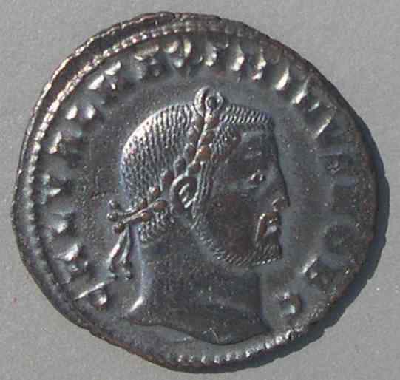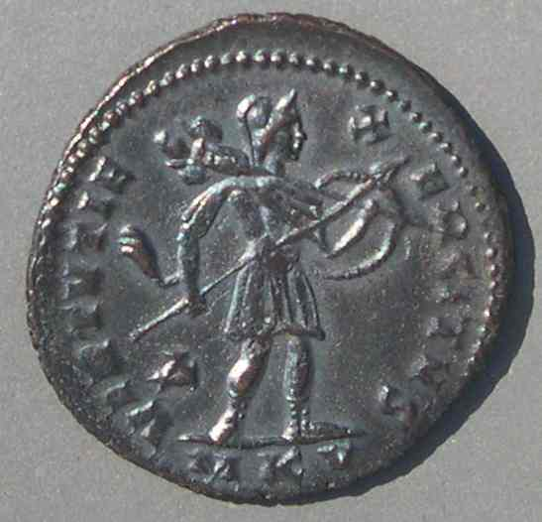  
**Coin 29  
  Maximinus II**, as Caesar  
  26 mm.  
  Struck late 308 - 309  
  at Cyzicus  
  GAL VAL MAXIMINVS NOB C  
  VIRTVTI EXERCITVS

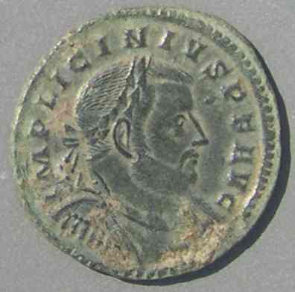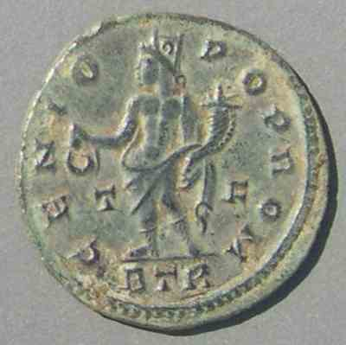**Coin 30  
  Licinius**, as Augustus  
  20 mm.  
  Struck late 308 - 309  
  at Trier, a mint of Constantine  
  IMP LICINIVS PF AVG  
  GENIO POP ROM

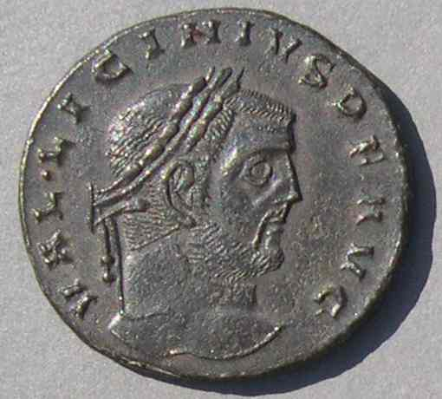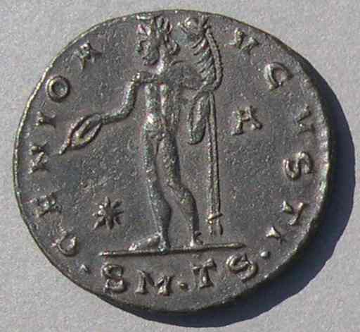  
  
**Coin 31  
  Licinius**, as Augustus  
  25-24 mm.  
  Struck late 308 - May 311  
  at Thessalonica  
  VAL LICINIVS PF AVG  
  GENIO AVGVSTI

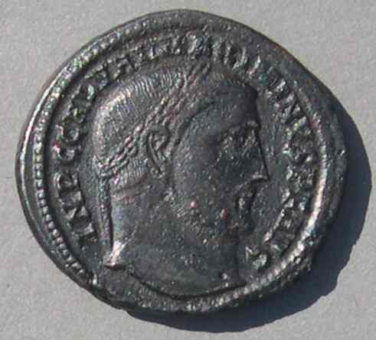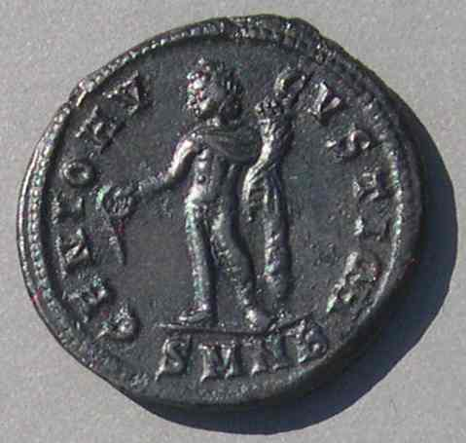  
   
**Coin 32  
  Maximinus II**, as Augustus  
  22 mm.  
  Struck 310-311  
  at Nicomedia  
  IMP C GAL VAL MAXIMINVS PF AVG  
  GENIO AVGVSTI CMH [elided]

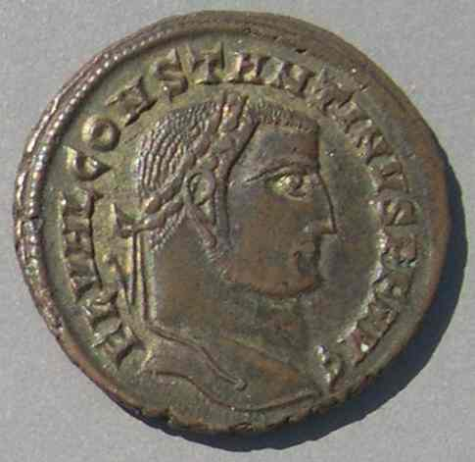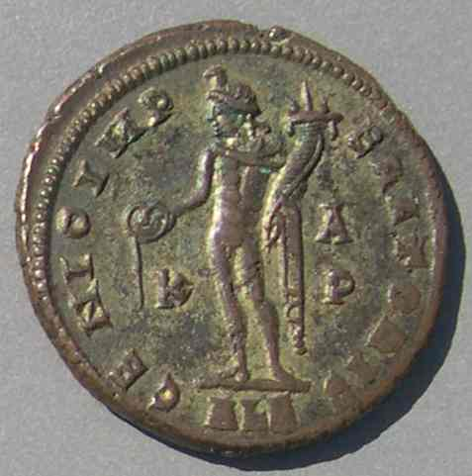**Coin 33  
  Constantine**, as Augustus  
  24 mm.  
  Struck mid 310  
  at Alexandria,  
  with the same controlmarks at the FIL AVGG issue [25][17]  
  FL VAL CONSTANTINVS PF AVG  
  GENIO IMPERATORIS

           In mid 309 an abortive attempt of Maximian to take power from Constantine resulted in Maximian's rapid defeat, his third retirement, and then his execution for still further plotting in 310. *RIC* gives no coins to the revolt of Maximian, nor to his third retirement.

           Meanwhile, the East was still minting FIL AVG coins. That episode came to an end when Maximinus II, dissatisfied with his long tenure as Caesar, had his troops proclaim him Augustus in mid 310 [[32](http://augustuscoins.com/ed/FILAVGG/#C32), [3](http://augustuscoins.com/ed/FILAVGG/#C3)].[17](http://augustuscoins.com/ed/FILAVGG/" \l "_edn17" \o ") This may have coincided with the beginning of Galerius's long terminal illness, which may explain why Galerius simply gave in to the pressure and confirmed both Maximinus and Constantine as Augusti. The FIL AVG issues were replaced by similar types with AVG [[33](http://augustuscoins.com/ed/FILAVGG/#C33)].

            The date is no major milestone. The pace of events continued unabated. Much remained to be sorted out before the list of five Augusti (Galerius, Maximinus, Constantine, Licinius, and Maxentius) was pruned down to one by Constantine. But that's another long story, and in it there is no Filius Augusti.[18](http://augustuscoins.com/ed/FILAVGG/" \l "_edn18" \o ")

The End

Comments and corrections are solicited. Write me at: e-mail

**Appendix: Mints during 306-310**

(listed more or less west to east)

London, Treveri (Trier), Lugdunum (Lyons), Rome, Ostia, Carthage, Ticinum, Aquileia, Siscia, Serdica, Thessalonica, Heraclea, Nicomedia, Cyzicus, Antioch, Alexandria.

**Notes**: The dividing line between West and East was usually between Aquileia and Siscia, or between Siscia and Serdica.

            London, Trier, and Lugdunum were an inheritance from Constantius and belonged to Constantine throughout this period.

            Antioch and Alexandria belonged to Maximinus II throughout this period.

            Ostia was opened by Maxentius in 308/309.

            Siscia closed with Severus' defeat and resumed minting when Licinius became Augustus.

            Serdica opened in 303 and closed in 308 before Licinius became Augustus.

            Thessalonica, closed since 303,  reopened as Galerius' principal Balkan mint when Licinius became Augustus [[26](http://augustuscoins.com/ed/FILAVGG/#C26), [31](http://augustuscoins.com/ed/FILAVGG/#C31)].

            In this period the mintmark prefix SM (Sacra Moneta) probably denotes principal mints that were striking gold.

[1.](http://augustuscoins.com/ed/FILAVGG/" \l "_ednref1" \o ") This article is derivative and not original research. It attempts to provide a comprehensible outline of the relationship between coins and events in the period containing the FIL AVGG issues. This outline is distilled from the hundreds of pages devoted to that period in *RIC*, *Roman Imperial Coinage*, volume VI, by C.H.V. Sutherland. I hope the necessary oversimplification has not become misrepresentation.

            The sequence of events is not entirely certain. (For example, was Constantine proclaimed Augustus by Maximian, or did he proclaim himself after Maximian had returned to Rome?) Furthermore, the precise dates on which some major events occur  (such as the elevation of Constantine to Augustus) are also uncertain. To remain consistent with the coin dates as given in *RIC*, the dates given throughout are those of *RIC*. A primary source is Lactantius, *De Mortibus Persecutorum*. A good secondary source with a slightly different sequence of events than *RIC* is *The Cambridge Ancient History*, volume XII.

            Illustrated coins are referred to by numbers in square brackets. *RIC* references are given by mint. In the captions, numbers in brackets refer to coins of closely related issues that help illuminate the sequence of events. The positioning of the brackets indicates whether the relationship is by obverse title, reverse type, or mint.

[2.](http://augustuscoins.com/ed/FILAVGG/" \l "_ednref2" \o ") RIC V.II spells it "Herculeus." RIC VI uses "Herculius." Here I use "Maximian" instead of the full "Maximianus" to help distinguish him from Maximinus II by using the "us" ending only for Maximinus II (= Maximinus).

[3.](http://augustuscoins.com/ed/FILAVGG/" \l "_ednref3" \o ") Constantius became Caesar March 1, slightly before Galerius was promoted to Caesar c. May 21.  *RIC* p. 9.

[4.](http://augustuscoins.com/ed/FILAVGG/" \l "_ednref4" \o ") Galerius married the daughter of Diocletian, Galeria Valeria. Coins were issued in her name 308 - 311. Constantius married Theodora, the step-daughter of Maximian. Coins were issued in her name only much later, possibly c. 337.

[5.](http://augustuscoins.com/ed/FILAVGG/" \l "_ednref5" \o ") Except Nicomedia, which never struck for the retired emperors. Because Diocletian was retired, his coins hardly reflect power shifts. Therefore, the mints striking his coins are not listed separately here. On the other hand, Maximian was in and out of power and the mints of his coins are tabled.

[6.](http://augustuscoins.com/ed/FILAVGG/" \l "_ednref6" \o ") The army was willing to hail Constantine Augustus, but his coins show he accepted the title Caesar.

[7.](http://augustuscoins.com/ed/FILAVGG/" \l "_ednref7" \o ") There are very rare exceptions at Trier (*RIC* 772) and Lugdunum (*RIC* 256) after Constantine became Augustus.

[8.](http://augustuscoins.com/ed/FILAVGG/" \l "_ednref8" \o ") *RIC*, p. 14, accepts the date of July 25, 307, and puts it distinctly after the wedding and Herculius' return to Rome. Some sources give the alternative date March 31. *The Cambridge Ancient History* has Herculius personally presiding over the promotion in Trier.

[9.](http://augustuscoins.com/ed/FILAVGG/" \l "_ednref9" \o ") With the rare exceptions noted in note 7.

[10.](http://augustuscoins.com/ed/FILAVGG/" \l "_ednref10" \o ") There are rare isues for both Galerius and Maximinus from Trier and Lugdunum under Constantine.

[11.](http://augustuscoins.com/ed/FILAVGG/" \l "_ednref11" \o ") Serdica, Nicomedia, Cyzicus, Antioch, and Alexandria omit Constantine, and Heraclea simply closes down! Siscia closed during this short period. Thessalonica was already closed.

[12.](http://augustuscoins.com/ed/FILAVGG/" \l "_ednref12" \o ") *RIC* accepts a date of November 11, 308, for the elevation of Licinius at the conference.

[13.](http://augustuscoins.com/ed/FILAVGG/" \l "_ednref13" \o ") *RIC*, p.525, mentions that, after Carnuntum, mints as far west as Heraclea showed uncertainty, "sharpened by some knowledge of Maximinus' feelings," about just how to title everyone. This would explain why Nicomedia, a Galerian mint, used the one-G style of Maximinus.

[14.](http://augustuscoins.com/ed/FILAVGG/" \l "_ednref14" \o ") The meaning of the elided CMH at Nicomedia and Cyzicus is not known [25, 35]. *RIC* sees it as numerical, but cannot make out its meaning.

[15.](http://augustuscoins.com/ed/FILAVGG/" \l "_ednref15" \o ") Placed in this time by Schulten, *Die Römische Münzstätte Trier*, 1974

[16.](http://augustuscoins.com/ed/FILAVGG/" \l "_ednref16" \o ") *RIC* therefore disagrees with Sear, *Roman Coins and Their Values* (4th edition), which assigns this coin, RIC (Ale) 90 = Sear 3650, to the second abdication period.

[17.](http://augustuscoins.com/ed/FILAVGG/" \l "_ednref17" \o ") Some writers put these promotions up to a year earlier, but these are the dates in *RIC*.

[18.](http://augustuscoins.com/ed/FILAVGG/" \l "_ednref18" \o ") The sequence was: Galerius died. Maxentius lost to Constantine. Maximinus lost to Licinius. Licinius tied one war and then lost a second to Constantine. Only one remained (A.D. 324).

AP 1